October 10, 2019

To: Danielle Sherman, CTO
From: Kevin Burr, Analyst

Subject: Market Basket Analysis of Electonidex Product Portfolio

Danielle,

You request I analyze Electronidex’s product transactions of the past 30 days performing a market basket analysis to identify relationships, or associations, between customers’ transactions and the products they purchased. You requested I try to determine:

- whether or not there are any interesting relationships or patterns within their transactions.
- whether or not I could help identify if Blackwell would benefit from selling Electronidex’s products.
- whether or not I would recommend purchasing Electronidex.
- if we do purchase them, are there product mix recommendations I would make (cross sell, discontinuance, promotions).

The transaction data set provided by Electronidex contained 9835 transactions, with 125 distinct items with a variety of distributions of those items across the transactions. The majority, 52% of transactions, contain 3 or less items:

1 item: 22%
2 items: 17%
3 items: 13%
Other: 48%

The following chart displays the top ten most commonly purchased items where the support was set to 10% - meaning these items show up in at least 10% of the transactions.

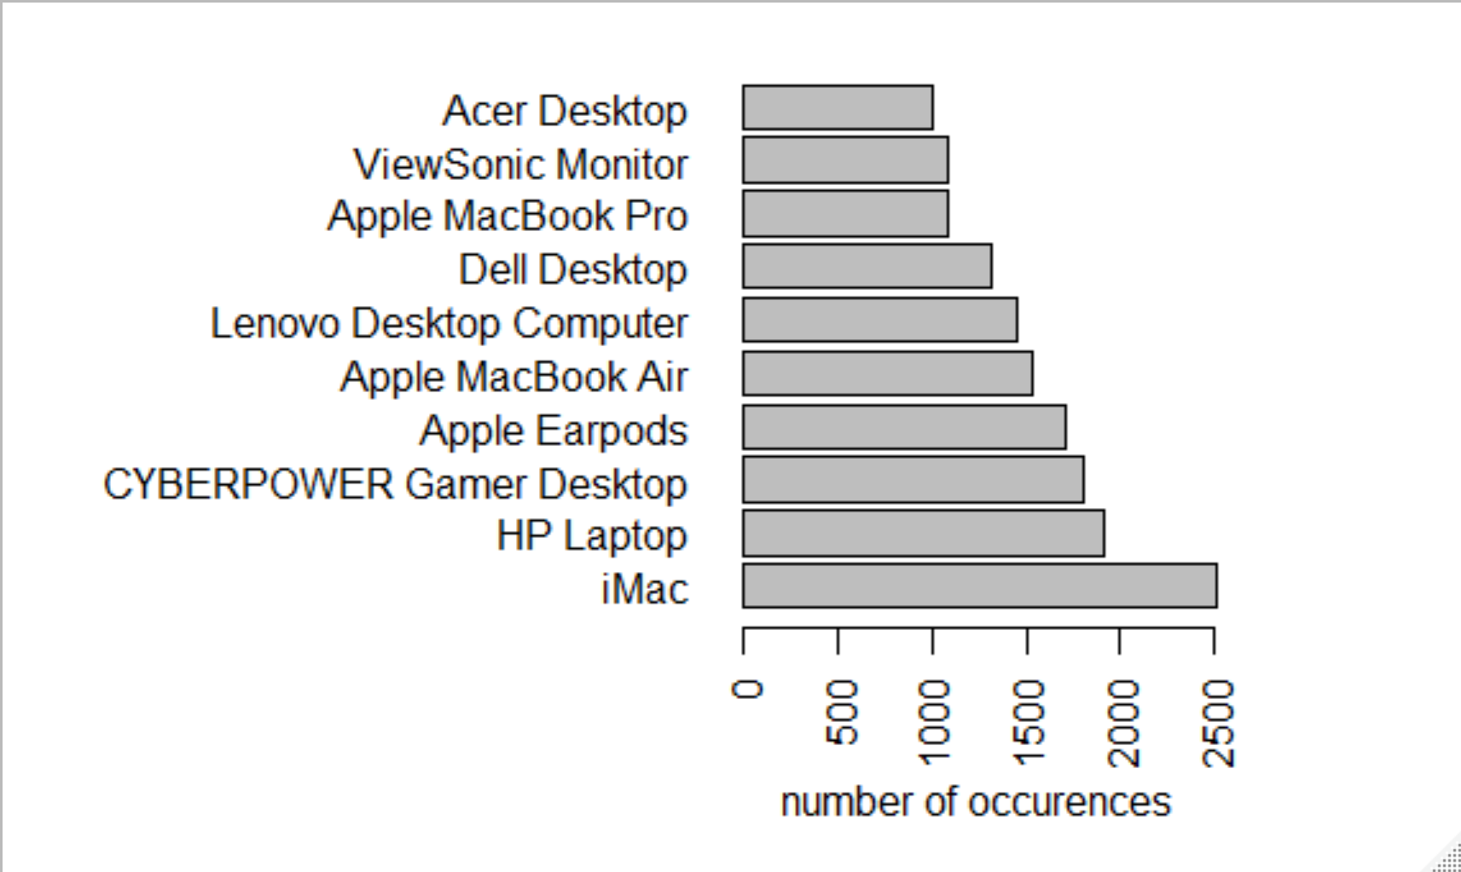

On average across the entire set of transactions reviewed, customers purchase 4 items at a time. This is skewed a bit by the fact that there are some large purchases (30 items for 1 for instance), but that is the exception rather than the rule as you can see the distribution of of number of items purchased being 52% of the time 3 items or less.

I generated a set of rules based on a number of different criteria to try to identify different patterns as directed. I focused on setting to variables at different intervals: support (defines how often the products occur together) and confidence (the probability that the presence of one product implies the presence of the other).

The data points to approximately 2.5% of transactions where clients purchase an iMac or HP Laptop, there is a high degree of confidence, or probability (40-49%), the customer would purchase at least one or the other of a monitor or keyboard. The lift is approximately2 in these cases, suggesting clients are 2x as likely to purchase a keyboard or monitor if they purchase an iMac or HP Laptop.

Next, I looked at transactions where a client purchases two items and tried to determine how this might impact purchasing a third. This generated 82 different possible combinations, defined by support of .01 and confidence of at least .3. Similar to above, this points to 1% of transactions where a customer purchased two items and there is a high degree of confidence (over 30%) they purchase a third item.

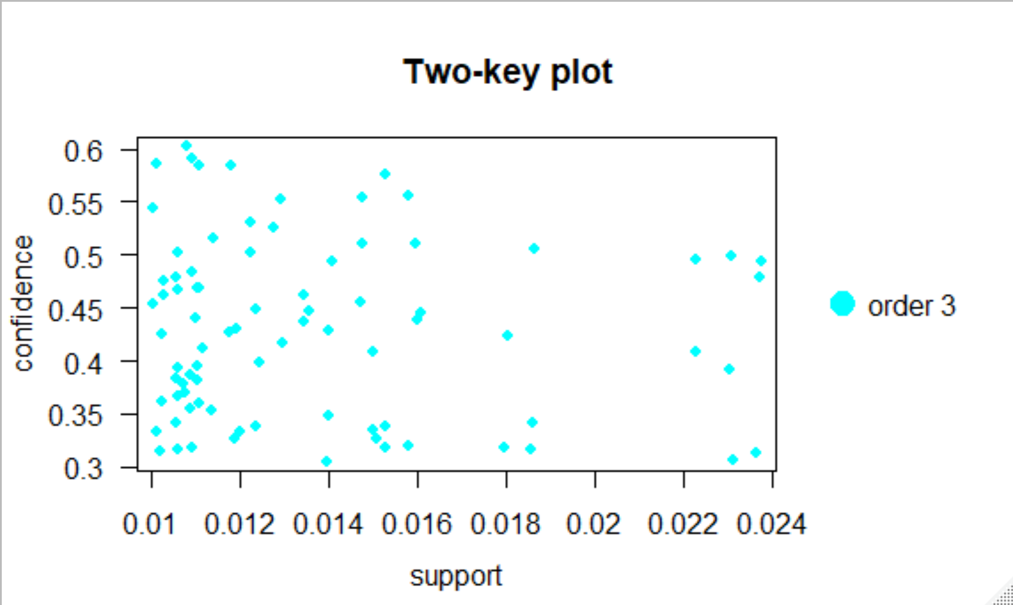
I focused on the top 5 with the highest confidence in this subset of transactions.

In the small set of transactions where there are three items, it is interesting to see that customers tend purchase an non-Apple laptop or desktop computer, and a monitor (which we saw in the prior section), but these transactions had a high degree of confidence (57-60%) that a customer would also purchase an iMac. For those transactions that were a desktop and monitor, the client tends to purchase a laptop, generally in these instances. The lift in these cases is also as high as 3, meaning a client purchasing a non-Apple computer and a monitor, is 3x as likely to purchase an iMac.

Next I reduced the support to .002, and confidence at .8 with a minimum number of items in the transactions set to 4. I noticed that customers who purchase more than one computer, tend to include a monitor, but also we start seeing peripherals being purchased, such as Keyboards and Computer Games. This analysis suggests that customers may be as much as 4x as likely to begin purchasing peripherals and accessories once they purchase more than one computer. While this analysis shows that customers tend to purchase desktops and monitors together, it also shows that customers purchase keyboards for iMacs as well. In fact, it could be inferred that if a customer purchases an iMac and a non-Apple desktop there is a high likelihood they will also purchase a monitor and an Apple keyboard (3-4x likely).

Looking at anything over 4 items total (up to 3 predicting a 4th), I needed to make support extremely small and confidence extremely low. So, I considered transactions with more than 4 items having a low likelihood of association or patterns being evident that would result in significant numbers of examples to drive business behavior for us.

I was also able to identify a strong association between iMac purchases and Apple related peripheral or accessory purchases, such as Apple Earpods. This seems fairly obvious though. Customers who purchase Apple products tend to purchase more Apple products since they are built to be used together.

A few rules generated didn’t help much, such as customers purchasing non-Apple laptops also purchased an Apple accessory such as ear pods. This may suggest these customers already own an Apple product and just didn’t purchase the Apple accessory at the time they purchased the Apple computer.

With respect to your question about whether or not Blackwell would benefit from selling Electronidex’s products, this is difficult to answer. From the analysis, it’s clear customers are willing to purchase more than one item at a time, and these additional items tend to be related. So, there is opportunity to cross-sell/upsell customers on peripherals, accessories when they purchase a computer. Additionally, customers appear to purchase more than one computer, with a mix in type – desktop, laptop, and Apple. So, there is opportunity to combine product sets and drive cross sell/upsell programs with the combined product portfolio.
That said, I would recommend an overlap analysis and discontinue carrying poorer performing computers and accessories, and those that completely overlap. This would create an optimal mix of in-demand computers and related accessories that customers would be interested in acquiring from a combined company.

To determine whether or not to purchase the company, I would also recommend a customer segment analysis to ensure the combined company does not cannibalize the existing customer base, but instead represents an extended and complimentary customer base for both product portfolios.

Should we decided to purchase the company, it does look like we could run promotions to drive sales on accessories for Apple computers and monitors for any computer. Additionally, we could offer some kind of incentive to purchase more than one computer which would drive sales in accessories. Finally, it appears, not all customers purchase accessories at the time they acquire a more expensive primary product like a computer or monitor. So, it could be interesting to run campaigns to drive these customers back to purchase accessories through some kind of discount email offers, or physical mail offers.

